Jeff Cohen

DIGM 580-004

2/16/16

**Progress Report 1**

**Game Assets**

Over the last week, I spent a great deal of time looking online for sample images to determine the look and feel for Cats-teroids. I want it to have a silly cartoonish feel but not be too cheesy. I approximate that I spent about 2 hours just searching for images. I was able to find a set of asteroids and a cartoon cat image on 2 different stock photo sites. I intend to alter the image of the cat by changing the color and adding a little more detail to match the asteroid set.

 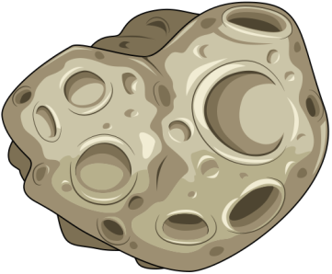 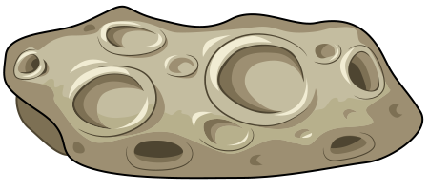

I then spent some time looking for and watching tutorials on designing mobile games. I spent about 2-3 hours on this endeavor and found the links below to be the most helpful. The sites do not cover exactly what I need but they gave me a better understanding for designing mobile games.

[Link 1](http://code.tutsplus.com/tutorials/create-a-2d-platform-game-with-unity-and-the-dolby-audio-api--cms-20863)

[Link 2](https://unity3d.com/learn/tutorials/modules/beginner/live-training-archive/mobile-development)

[Link 3](https://unity3d.com/learn/tutorials/modules/beginner/platform-specific/multitouch-input?playlist=17138)

I also began creating my own cartoon space cannon in Adobe Illustrator. It still needs color and detail. This only took an hour. I also took some time to set up the game environment, background, aspect ratio and folders in Unity (perhaps another hour).

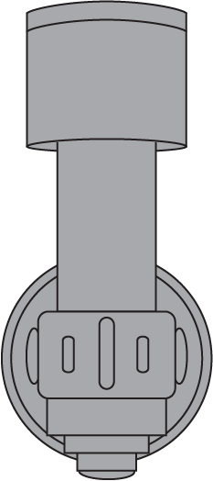

**Approximate Total Hours Worked: 7-8**

**Outcomes**

Overall, I am pleased with the images I found for the cat, asteroids and space background. I’m not certain about the space cannon as it is still a work in progress.

The hurdles I had to overcome this week were determining the look and feel of my game and spending time learning about mobile game development. This is still an area of weakness for me as I’m not sure how the touch input and code will work specifically for my game. I am still uncertain about the size of the game environment and the platform for which I should develop it. Currently, I have the build set to iOS and the aspect ratio set to the general iPhone tall (2:3). I also learned about the use of Unity Remote for mobile development and need to explore this option for designing and testing my game. These are issues I will need to discuss in the next class meeting.

**Next Steps**

For the next week, I will finish my space cannon and begin setting up the sprites and other assets in the game environment. I will watch tutorials as needed and start compiling relevant scripts from other games I have created. My goal is to have a very basic build with some game functionality for next class.